Post title: | Senior Planning Assistant
Grade: | H
Responsible to: | Planning Technical Supervisor
Staff managed: | None
Directorate: | Community Development
Service: | Planning
Job family: | P&T - Professional & Technical
Date of issue: | November 2023
Job context
- The Council’s Planning Services play a fundamental role in managing the natural and built environment, ensuring that the future development needs of the county can be accommodated to make it a better place in which to live and work. It is one of the largest planning functions in the country covering one of the largest geographical areas including national parks, areas of outstanding natural beauty, to small market town and large urban areas.
- The Operations team are responsible for many technical aspects of case processing across the range of responsibilities within the Planning Service – including Development Management, Building Control, Policy & Place, Infrastructure and Delivery, Land Charges, Street Naming & Numbering, data management, system use. Senior Planning assistants play a vital role in supporting the work of the planning service and building control including determination a numerous types of minor cases, as well as relevant system expertise.
- The post holder will work within a team providing a wide range of specialist technical support services across the whole of the Planning service, to ensure efficient, effective and compliant service delivery. Undertakes work across a diverse range of back office and ‘front of house’ support services within a busy customer-facing environment
- The duties and responsibilities highlighted are indicative and may vary over time. The post holder is expected to undertake other duties and responsibilities relevant to the nature, level and scope of the post.

Job Purpose: | To provide technical support for case processing for the more complex aspects of the range of tasks which the Planning service is responsible for – including Development Management, Building Control, Policy & Place, Infrastructure and Delivery, Street Naming & Numbering, Land Charges, data management, information governance and business improvement. This role also includes the responsibility to determine many types of minor case workload, or to be an expert users of relevant systems – for example GIS.

Operational management: | - Process and manage minor applications and cases to decision to ensure efficient, effective and compliant delivery of customer-facing technical Planning and Building Control services e.g Permitted Development enquiries, Tree works, householder applications, Street Naming & Numbering applications  - Undertake site visits to assess acceptability of proposals  - Negotiates with professional agents on formal submissions – for example the acceptability of minor case work such as tree works of small householder extensions or determining if planning permission or building regulation approval is required and for which aspect of proposals  - Provides technical support across a diverse range of service activities, including carrying out survey work – e.g Tree Preservation Orders or site allocation.  - Registering and validation of the most complex cases and notifications. Scrutinizing and verifying the drawings, background documents and fees submitted. Deciding whether the details are in line with the national and local validation requirements as applicable to the type of application/notification.  - Liaising with agents and applicants where necessary prior to validation. This includes the plotting and constraint checking in the relevant case management system  - Processing of Information Requests – eg FOI, EIR  - Ensure that relevant Business Intelligence information is collected, held, managed and appraised to inform decision making, policy development and project delivery (including but not limited to a wide range of performance management data, legislative reporting requirements, project information and customer feedback)  - Develop and maintain systems and processes to support the effective and efficient running of an operational service and to ensure the high quality of information held. – for example Captures/imports data into a wide range of information and intelligence systems as/when required  - Undertakes a wide range of communication and engagement activities to support the work of the service – such as updates to Parish Councils, Local Plan related events for both business professionals and the public, attending both in the office and in community venues, this includes both arranging and facilitating events.  - Uses Business Improvement methodologies to identify and improve working practises  - Undertakes a project support role in collaboration with other council resources for a wide range of service projects - organise meetings, briefings, training sessions with/for officers, staff, members and third parties including diary management, bookings, papers, IT support, training materials, and produce agendas, minutes and action sheets. Will also undertake small scale project relating to improving working practises  - To resurrect historic/dormant applications, source information from the County Archivist and enable the progression of the application to a satisfactory conclusion.  - Working with finance colleagues dealing with both creditors and debtors to ensure cases are paid for and funds correctly allocated  - Manage own workload in a proactive manner to ensure the customer receives a focused service that meets the required the performance targets  - Assist with the training and guidance of other planning operations staff  - Assist team managers to ensure delivery of an efficient and effective service.  - Carry out other appropriate duties as required by the service and use initiative to deal with enquiries which may be of a non-routine in nature.  - Contribute to the development of the Operations team.  - Establish and maintain effective relationships with customers including Councillors, other members of staff and outside agencies.  - Contribute to the delivery of a proactive and customer-focused service in line with our shared ‘one team’ vision  - Contribute to service transformation and improvement work and look for opportunities to continuously improve own performance.
Resource management: | - Handle incoming cheques and electronic payments to allocate and maintain accurate records of transactions.  - With finance collegues deal with creditors and Debtors relevant to own cases
Partnerships: | - Build and develop strong working relationships across the service, and the wider council, in order to support the objectives of the Planning Service  - Liaise with customers and external partners and other service providers as required.
Communications: | - Liaise with applicants and agents regarding validity of submissions, fee guidance, process and acceptability of proposals  - To resolve and respond to complex service requests from all stakeholders and deal with all manner of general queries, including fee guidance, whilst prioritizing the customer and their requirements; and managing circumstances to enable a positive resolution for all concerned wherever practical. This may involve challenging, and potentially conflicting situations on site, at events with members of the public, councillors and business professionals
Systems and information: | - Act as service systems expert/ super-user undertaking complex pieces of work linked to the range of systems use in planning – for example GIS.  - Manage, interrogate and enhance data held within Planning Information systems  - Carry out mandatory and non-mandatory consultations and neighbour notifications for valid cases. Accurately record, process and publish documents in the Electronic Document Management system for public viewing in line with data protection.  - Responsible for the closure and of all cases including updating the relevant case management system and Statutory Registers and ensuring all documents have been captured in the Electronic Document System.  - Update and maintain accurate records in the relevant case management system.  - Electronically file and maintain documents in the Document Management System and arrange retrieval of documents.
Safeguarding: | - Comply with the requirements of Health and Safety legislation and with the Council’s policies and procedures.  - Comply with the requirements of General Data Protection Regulations and all such related legislation, always maintaining confidentiality.  - Comply with the Council’s commitment to Equality and Diversity  - Comply with all policies and procedures of the Council relevant to the role.

Person Specification:
Essential | Desirable
Knowledge and Experience  - A broad knowledge and experience of the range of Planning and building control and related technical work areas  - Working with systems and data – preferably with a spatial aspect  - Dealing with customers and professional agents, in potentially conflicting situations  - Experience of data management including manipulating large data sets and producing complex reports ensuring accuracy and where appropriate confidentiality.  - Experience of business intelligence and analytical tools to interrogate large and complex datasets  - Experience of managing and prioritising own workload  - Experience of providing the day to day support to services, partners and providing support in a busy environment · | - Knowledge of working to statutory and legislative standards relevant to the planning function  - Knowledge of operational issues relevant to the planning function
Occupational Skills  - Effective communication skills, including the ability to relate well to customers at all levels.  - Effective time management and organisational skills.  - Ability to use IT resources to support the functions of the post (input/extract data/word processing/spreadsheets.  - Ability to work well within a team environment  - Ability to provide authoritative advice and guidance to deal with complex queries and to induct and train staff.  - Ability to present/record difficult information in an accessible format suitable for a varied audience.  - Ability to analyse, organise and present numerical data.  - Good attention to detail, ability to negotiate and influence others , good organisational skills, ability to work under with limited supervision and self-motivated, ability to prioritise work and work to tight deadlines. | - Ability to support the development of other staff.
Behaviours
link

Qualifications  - 5 GCSE or equivalent | - Level 3 NVQ Diploma in Town Planning Technical Support or experience of working in this sector
Other Requirements  - Able to provide support to services outside normal working hours, as and when required.  - Ability to travel around the County and willingness to work flexibly including evening and weekends  - Willingness to continual professional development | - Interest in planning, and or building control

Career progression:
- At NYC we value our employees, and as part of this we can provide wider opportunities to progress in your career. Through discussion with your manager identify areas of interest and consider avenues to progress to them, e.g. apprenticeships and work shadowing/coaching.
- As a large council we have a range of roles, across our services, and can provide a wealth of career and development opportunities to help our employees find fulfilling career development opportunities.

Structure
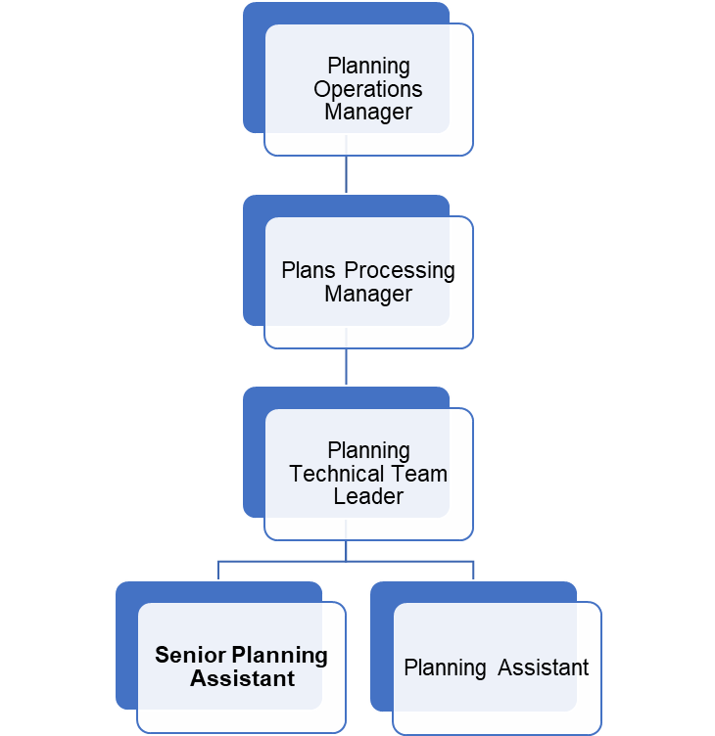
NB – Assessment criteria for recruitment will be notified separately.
Optional - Statement for recruitment purposes: You should use this information to make the best of your application by identifying some specific pieces of work you may have undertaken in any of these areas. You will be tested in some or all of the skill specific areas over the course of the selection process

