Post title: | Systems and Applications Operations Engineer
Grade: | Grade G-I
Responsible to: | Systems and Applications Product Owner  Systems and Applications Product Manager
Staff managed: | None
Directorate: | Resources
Service: | Technology
Job family: | P&T - Professional & Technical
Date of issue: | March 2024
Job context
North Yorkshire Council (NYC) Technology Services provides effective ICT services across the North Yorkshire region, supporting 10,500 staff and 625,000 citizens. We enable the organisation and its partners to achieve their operational outcomes, driving innovation and efficiency to continually improve ICT services both within the council, and externally to businesses, communities, volunteers, and providing a commercial offering to public and private sector customers. With NYC’s transformation from eight separate local government organisations into one unitary authority in 2023, Technology Services provides a critical role to consolidate, improve and develop our networks, infrastructure and systems.

The Technology Systems and Applications Team (TSAT) lead on the consolidation and convergency of systems and applications, maximising re-use and recycle wherever possible to ensure best value. Maintenance of excellent service provision and positive proactive development are essential as systems are centralised, streamlined, and improved.

TSAT work to ISO 20,000 and 27,001 standards, regularly partaking in audits and reviews ensuring ongoing compliance is maintained. These accreditations represent the backbone of the Technology Service offering, demonstrate an ongoing commitment to both security and service excellence, as well as forming a crucial part of NYC’s Technology Service commercial viability.

As a Systems and Applications Operations Engineer you will support the technology service and TSAT product and service teams through the ongoing support, development and provision of systems and application services. Working as part of a small product team the role focuses on gaining ‘expert’ user status across a portfolio of applications providing efficient, effective and timely support to all customers, thereby ensuring organisational objectives are achieved.
Occasional out of hours working may be required.

Whilst operating a hybrid working model, work may require the post holder to occasionally travel for work purposes across the North Yorkshire County. If your base location is a locality hub you will be expected to be a part of the on-site presence in that location on a regular basis.

As a member of our Technology team and in line with our customer centric ethos, you should guide and advise users who may need help and support while you are at your locality hub regardless of your team or your role.

The Systems and Applications Operations Engineer is a career graded post.
Progression from Grade G to I requires minimum 24 months relevant experience and is dependent on achieving specific criteria, sponsorship from your line manager, approval from the TSAT management team and business need. This process will usually also involve a suitability assessment.

These requirements are detailed in this job description.
Post | Qualification, training and experience required to either enter, or progress.
Systems and Applications Engineer – Grade G | Entry level position. Minimum requirements can be found below within the job description.
Systems and Applications Engineer (Senior) – Grade I | - ITIL Service Management accreditation in a relevant subject pertaining to the post or equivalent.  - Lead on systems / applications vendor engagement sessions as per agreed schedule in accordance with their risk and value to the organisation on a repeated and routine basis.  - Advanced administration of systems and applications within the portfolio – evidenced ability to routinely self-diagnose and resolve complex systems issues or incidents.  - Advanced usage and competency of the Microsoft 365 estate. Is able to demonstrate on a variety of products and software packages.  - Have sufficient experience, knowledge, and expertise to work independently and without supervision for of all critical procedures across systems and applications, including supplier management.  - Have sufficient experience, knowledge, and expertise to work independently and without supervision for of all critical systems required for any out of hours’ support.  - Provision of independent Out of Hours support via rota when required.  - Creation and maintenance of 20, good quality, knowledge base articles, published on the Technology Self Service portal OR internal TSAT knowledgebase.  - Actively support and evidence the ownership and compliance of supported applications against the ISO 20,000 and 27,001 standards as internally audited by the Systems and Applications Governance and Compliance Team.  - Demonstrate ownership and understanding of at least one Service Management practice not covered by the standard practices adopted across all teams (exclusions include Incident, Request, Problem, Change) leading on the training, adoption, utilization, planning and dissemination of activity across the team.  - Be able to evidence quarterly updates to the Systems and Applications Systems Lifecycle Document for supported products.  - Be able to demonstrate the successful upgrades of applications on a routine basis whereby no issue nor problem (caused through lack of due diligence) occurred.  - Manage the process of ‘user testimony’ in support of your application for promotion. This invites a senior stakeholder (outside of Technology) and as approved by your line manager to provide a written testimony in support of the work you have done, the value you have added and the approach with which it was undertaken.  - Satisfactory routine performance and appraisals  - No active disciplinary nor sickness / attendance process within the last 18 months  - 24 months experience within a TSAT product team

Progression from Grade G to I requires minimum 24 months experience in the post and is dependent on achieving the criteria above, sponsorship from your line manager and approval from the TSAT management team. This process will usually involve a brief (15 minute) presentation on your learning journey, followed by a 15-minute Q&A

Job Purpose: | The core focus of this job is to lead and manage the development and provision of services and to be responsible for the effective operation of key ICT systems ensuring the highest standards of service are given at all times.

Operational management: | Entry level Systems and Applications Engineer Responsibilities (grade G)  - Support the implementation and on-going development of IT systems in business areas in accordance with agreed operational and implementation plans.  - Work closely with colleagues and business areas across NYC to understand, analyse and facilitate improvement to business processes aligning them to relevant and effective IT systems.  - Demonstrate good knowledge of each system’s capabilities and in conjunction with and support from colleagues, system users and suppliers review functionality to ensure that systems continually meet changing business needs.  - Support the development and implementation of systems ensuring they meet local and national agendas and targets.  - Support the development of procedures and guidance to ensure the efficient operation of systems and associated tasks.  - Working with your line manager, effectively manage individual workloads to support business as usual and project related activity to ensure that service levels and project deliverables are met.  - With support, and utilising existing processes, be able to estimate, to a reasonable degree of accuracy the length and complexity of certain administrative IT functions. required to deliver work packages.  - Champion the needs of our customers through the delivery of IT related services, in addition to advocating good use of IT across NYC.  - Ensure a high quality third-line support service, supplying expert solutions to problems in-line with agreed service levels.  - Support and co-ordinate the thorough testing of system upgrades and enhancements whilst adhering to the technical change and release management processes.  - Develop effective working relationships with systems’ suppliers monitoring and escalating issues to ensure resolution within contractual service level agreement.  - Support the Identification of training and development needs of the business, working with colleagues to produce training plans, training documentation and guidance materials for all corporate systems.  - Support the process of robust evaluation of learning to ensure that training and development meets the future needs of the organisation.  - Support colleagues to engage with workforce development to provide regular structured training on NYC’s information systems, as appropriate. This may include being in a classroom-based environment, providing support to other TSAT team members who will lead on training programmes.  - Working with colleagues throughout NYC, support arrangements to deliver user-defined report writing, production of Management Information and data analysis.  - Publish content on the web through the use of e-forms and other technologies.  - Ensure that database integrity and data quality used locally and fed into national systems is of the highest accuracy. Assist in developing procedures to continuously improve data quality from sources within and outside the Authority.  - Support the development of action plans for both internal and external partners to ensure improvements in data management.  - Support the development of new more efficient ways of working, influencing both senior and middle management to embrace changes to IT systems and new working practices that will be rolled out to end users.  - Work closely with system users to resolve errors, inaccuracies, and exceptions in information systems, for example, duplicate records. Providing training and guidance where required.  - Ensure the enforcement of FOI and data protection policies and processes.  - Support internal and external audit processes and any associated system audit actions.  - Follow agreed escalation processes for any system risks or issues, taking ownership and communicating appropriately.  - Represent NYC at internal and external user group sessions, special interest groups and events disseminating useful information gained.  - Contribute to the proactive monitoring of service levels responding as required to ensure quality of service is maintained  - Such other duties commensurate with the grading and job description of the post that may be required.  Senior Systems and Applications Engineer Responsibilities (grade I)  - Lead the implementation and on-going development of IT systems in business areas in accordance with agreed operational and implementation plans.  - Work closely with business areas across NYC to understand, analyse and facilitate improvement to business processes aligning them to relevant and effective IT systems.  - Demonstrate expert knowledge of each system’s capabilities and in conjunction with system users and suppliers review functionality to ensure that systems continually meet changing business needs.  - Lead the development and implementation of systems ensuring they meet local and national agendas and targets.  - Develop procedures and guidance to ensure the efficient operation of systems and associated tasks.  - Effectively manage individual workloads to support business as usual and project related activity to ensure that service levels and project deliverables are met.  - Draw on system knowledge and expertise to effectively estimate the tasks and resource required to deliver work packages.  - Be actively involved in the selection, enhancement, and development of IT systems to support the activities of business areas and ensure they are aligned to T&Cs requirements.  - Champion the needs of our customers through the delivery of IT related services, in addition to advocating good use of IT across NYC.  - Ensure a high quality second and third-line support service, supplying expert solutions to problems in-line with agreed service levels.  - Work proactively to identify and support the implementation of service improvement initiatives to increase customer satisfaction.  - Lead and co-ordinate the thorough testing of system upgrades and enhancements whilst adhering to the technical change and release management processes.  - Develop effective working relationships with systems’ suppliers monitoring and escalating issues to ensure resolution within contractual service level agreement.  - Identify training and development needs of the business and produce training plans, training documentation and guidance materials for all corporate systems.  - Undertake robust evaluation of learning to ensure that training and development meets the future needs of the organisation.  - Engage with workforce development to provide regular structured training on NYC’s information systems, as appropriate. This may include delivering up to 5-day training courses to groups, in addition to one-to-one training, using a range of training methods and at a range of locations. The frequency will depend upon need but could be applied weekly.  - Working with colleagues throughout NYC, support arrangements to deliver user-defined report writing, production of Management Information and data analysis.  - Publish content on the web through the use of e-forms and other technologies.  - Ensure that database integrity and data quality used locally and fed into national systems is of the highest accuracy. Assist in developing procedures to continuously improve data quality from sources within and outside the Authority.  - Develop action plans for both internal and external partners to ensure improvements in data management.  - Develop new more efficient ways of working, influencing both senior and middle management to embrace changes to IT systems and new working practices that will be rolled out to end users.  - Work closely with system users to resolve errors, inaccuracies, and exceptions in information systems, for example, duplicate records. Providing training and guidance where required.  - Ensure the enforcement of FOI and data protection policies and processes.  - Support and facilitate internal and external audit processes and any associated system audit actions.  - Follow agreed escalation processes for any system risks or issues, taking ownership and communicating appropriately.  - Represent NYC at internal and external user group sessions, special interest groups and events disseminating useful information gained.  - Contribute to the proactive monitoring of service levels responding as required to ensure quality of service is maintained.  - Such other duties commensurate with the grading and job description of the post that may be required.
Resource management: | Entry level Systems and Applications Engineer Responsibilities (grade G)  - Contribute to the co-ordination of project or work groups when required.  - Provide support, sharing knowledge and expertise with other team members and colleagues.  - Contribute to the effective use of available resources such as systems, software, and people.  - Support the standards and practices in places across TSAT by maintaining the centralised repository of system documentation and knowledge articles to promote a culture of shared best practice.  Senior Systems and Applications Engineer Responsibilities (grade I)  - Co-ordinate project or work groups when required.  - Provide support, sharing knowledge and expertise with other team members and colleagues.  - Ensure the most effective use of available resources such as systems, software, and people.  - Manage and maintain a centralised repository of system documentation and knowledge articles to promote a culture of shared best practice
Partnerships: | Entry level Systems and Applications Engineer Responsibilities (grade G)  - Can adapt to changing technologies to support the development of business process and systems.  - Can identify areas of potential process improvement and will highlight these to their line manager.  - Run reports on supplier performance to support the process of service level monitoring.  - Identify and improve local processes to improve the quality of data and information across systems.  - To work directly with associated services to ensure that our work is joined up and coordinated.  Senior Systems and Applications Engineer Responsibilities (grade I  - Promote an environment of openness and innovation where colleagues understand the changes being proposed through system improvement activity and are encouraged to engage in a positive manner.  - Appropriately challenge business processes to ensure NYC service teams are able to use systems to their full potential.  - Work closely with suppliers monitoring service levels.  - Liaise with third party organisations to establish effective data sharing arrangements.  - Develop local working arrangements and best practice processes to control and improve the quality of data across systems.  - To work directly with associated services to ensure that our work is joined up and coordinated.
Communications: | Entry level Systems and Applications Engineer Responsibilities (grade G)  - Can demonstrate good written and oral communication skills.  - Can partake in and maintain effective communication between internal and external colleagues, clients, suppliers and ensure collective information sharing.  - Consume best practice from colleagues and other relevant national organisations and other Local Authorities  - Produce project and business as usual updates, as required.  Senior Systems and Applications Engineer Responsibilities (grade I)  - Apply excellent written and oral communication skills.  - Establish and maintain effective communication between internal and external colleagues, clients, suppliers and ensure collective information sharing.  - Share best practice with relevant national organisations and other Local Authorities  - Produce project and business as usual updates, as required.
Systems and information: | Entry level Systems and Applications Engineer Responsibilities (grade G)  - With support from colleagues effectively support and understand the functionality and capabilities of the IT systems across NYC’s portfolio of supported systems  - Have an awareness of the personal responsibility to ensure data security and confidentiality.  - Support and shadow the process of systems development and data integration, taking on more responsibilities to undertake duties independently over time.  - Ensure key system information is accessible to the customer base in a timely manner through a variety of technologies.  Senior Systems and Applications Engineer Responsibilities (grade I)  - Become system expert in the functionality and capabilities of the IT systems across NYC’s portfolio of supported systems.  - Take personal responsibility to ensure data security and confidentiality.  - Lead in the support and development of systems and data integration.  - Ensure key system information is accessible to the customer base in a timely manner through a variety of technologies.

Person Specification:
Essential | Desirable
Knowledge and Experience  Entry level Systems and Applications Engineer essential criteria (grade G)  - Understanding of the role of information systems in supporting business needs and processes.  - An awareness and understanding of IT industry best practises and procedures.  - Theoretical knowledge of business processes relating to services supported by key corporate systems, as appropriate.  - Experience as an information system user  - Experience of dealing with IT incidents and associated problem management  - Experience in supporting, implementing, and developing large information systems.  - Experience of maintaining high levels of data quality  - Experience of using reports, extracts or analytical tools to interrogate datasets.  - Proven skills and confidence in the use of standard office software, IT systems and a willingness to undergo further training.  - Experience of supporting projects to deliver particular outcomes.  - Excellent customer care skills, including the ability to listen, interpret and understand requirements.  Senior Systems and Applications Engineer essential criteria (grade I)  - Understanding of the role of information systems in supporting business needs and processes.  - Good understanding of IT industry best practises and procedures  - Theoretical knowledge of business processes relating to services supported by key corporate systems, as appropriate.  - Significant experience as a large information system user.  - Significant experience of dealing with IT incidents and associated problem management  - Significant IT experience in supporting, implementing, and developing large information systems.  - Experience of maintaining high levels of data quality on a relational database.  - Experience of business intelligence and analytical tools to interrogate large and complex datasets.  - Experience of monitoring service levels  - Proven skills and confidence in the use of standard office software, IT systems and a willingness to undergo further training.  - Experience in developing training plans and of training staff, both internal and external to NYC.  - Can demonstrate project management experience.  - Excellent customer care skills, including the ability to listen, interpret and understand requirements | Entry level Systems and Applications Engineer desirable criteria (grade G)  - Knowledge of ISO27001  - ICT security practices  - Knowledge of Local Government business processes.  - Knowledge in relevant systems  - Understanding of IT service delivery  - Logging calls with suppliers and escalating issues  - Experience of using change, incident and problem management systems  Senior Systems and Applications Engineer desirable criteria (grade I)  - Knowledge of ISO27001  - ICT security practices  - Knowledge of Local Government business processes.  - Expert knowledge in relevant systems  - Awareness of service delivery in an ICT environment  - Working with suppliers, their services and contracts.  - Experience in the relevant line of business you will be supporting.  - Experience of using change, incident and problem management systems  - Experience of coding/ scripting in multiple languages, including visual basic, xml, SQL and html.  - Experience of Java and CSS.  - Experience of publishing intranet and internet-based content.
Occupational Skills  Entry level Systems and Applications Engineer essential criteria (grade G)  - Good communication skills, both oral and written  - Good organisational and administrative skills  - Ability to prioritise workload effectively.  - Can work within a fast-paced environment being able to respond quickly and efficiently to changing priorities.  - Good interpersonal skills.  - Self-confident and self-motivated manner.  Senior Systems and Applications Engineer essential criteria (grade I)  - Excellent communication skills, both oral and written.  - Excellent organisational and administrative skills.  - Ability to influence internal and external staff at both senior and middle management levels to enable new ways of working.  - Ability to prioritise workload effectively.  - Works productively in a pressurised environment.  - Makes decisions within own area of responsibility.  - Good interpersonal skills  - Self-confident and self-motivated manner | Entry level Systems and Applications Engineer desirable criteria (grade G)  - Experience of dealing with challenging customers  Senior Systems and Applications Engineer desirable criteria (grade I)  - Confidence to challenge barriers to effective practice
Behaviours
- link
Professional Qualifications  Entry level Systems and Applications Engineer essential criteria (grade G)  A professional qualification or demonstrable relevant experience in IT or a systems environment.  Senior Systems and Applications Engineer essential criteria (grade I)  A professional qualification or demonstrable relevant experience in IT or a systems environment. | Entry level Systems and Applications Engineer desirable criteria (grade G)  - ITIL Service Management qualification  Senior Systems and Applications Engineer desirable criteria (grade I)  - Prince 2 (or equivalent project management qualification)  - ITIL Service Management qualification  - Training Qualification
Other Requirements
- Ability to travel across the County.
- Ability to work flexibly, occasionally working outside of standard working hours to deliver projects and deploy changes.
- Ability to respond to incidents outside of normal business hours

Career progression:
- At NYC we value our employees, and as part of this we can provide wider opportunities to progress in your career. Through discussion with your manager identify areas of interest and consider avenues to progress to them, e.g. apprenticeships and work shadowing/coaching.
- As a large council we have a range of roles, across our services, and can provide a wealth of career and development opportunities to help our employees find fulfilling career development opportunities.
- This role has defined progression from Grade G to Grade I pay bands.
- Progression from Grade G to I requires minimum 24 months relevant experience and is dependent on achieving the criteria above, sponsorship from your line manager, approval from the TSAT management team and business need. This process will usually also involve a suitability assessment.

Within the Technology Service, the structure below identifies opportunities in the service with red lines indicating role specific progression and blue lines indicating suggested progression routes.

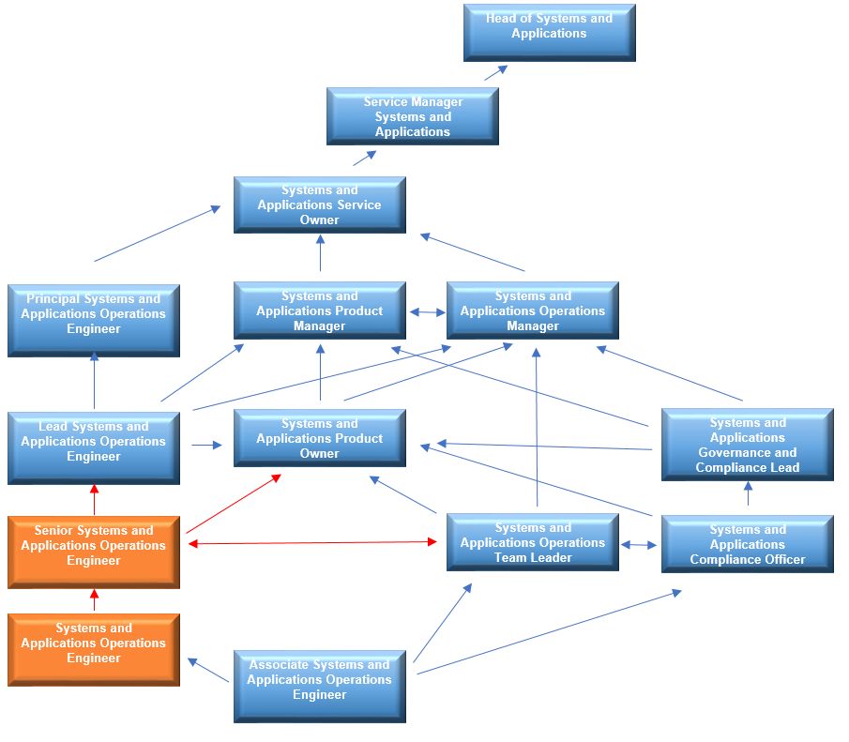

Structure
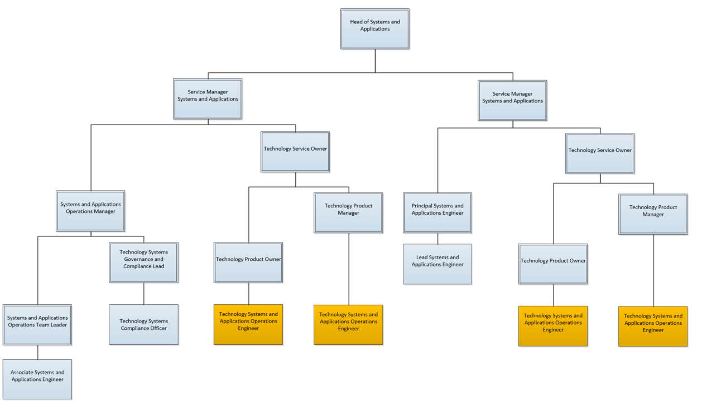

NB – Assessment criteria for recruitment will be notified separately.
Optional - Statement for recruitment purposes: You should use this information to make the best of your application by identifying some specific pieces of work you may have undertaken in any of these areas. You will be tested in some or all the skill specific areas over the course of the selection process.

