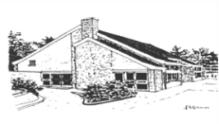 | NAWTON AND ROSEDALE ABBEY FEDERATION  Federation Headteacher: Nichola Oxtoby |  |  | 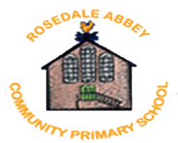
Nawton Community Primary School,  School Lane,  Nawton,  York,  North Yorkshire  YO62 7SF  Telephone: 01439 771245  Email: admin@nawton.n-yorks.sch.uk |  |  | Rosedale Abbey Community Primary School,  Rosedale Abbey,  Pickering,  North Yorkshire  YO18 8SA  Telephone: 01751 417278  Email: admin@rosedaleabbey.n-yorks.sch.uk
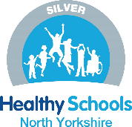 | ‘To nurture our SPIRIT’

Key Stage 2 Teacher
Salary: Main Scale 1 - 6
Hours: Full Time
Contract: Temporary (for 1 year in the first instance)
Closing date: 9am Friday 21st June 2024
Interviews and observations: Wednesday 3rd July 2024
Dear Potential Candidate,

Thank you for taking an interest in our exciting vacancy, we strongly recommend that you visit our Federation, please contact Penny Harper, Federation Administrator to arrange your visit:

admin@nawton.n-yorks.sch.uk
Telephone number - 01439 771245

The Nawton and Rosedale Abbey Federation is looking to appoint a dedicated, highly motivated and enthusiastic teacher to join our Key Stage Two Team at Nawton Community Primary School, teaching our mixed age Year 3 and 4.

We are looking for an excellent practitioner who:

- has high standards and expectations for themselves and others.
- has the drive and commitment to ensure that children achieve the highest outcomes.
- a teacher who loves working with children and cares greatly about their
success.
- a team player who recognises the joy and challenges of working across two busy
village schools

This vacancy would suit a Newly Qualified Teacher or an Early Careers Teacher with 1 or 2 years of teaching experience.

In return, we can offer you:

- Two happy schools in which everyone is valued and respected.
- Hardworking, enthusiastic and happy children, who are at the heart of
all we do.
- An exciting and inspiring learning environment.
- The support of our staff team, who work closely to achieve the best
for our children and each other.

Our federation consists of two vibrant, creative and supportive community primary schools situated approximately twelve miles apart. Both schools are at the heart of their communities.

Nawton Community Primary School – 98 on roll

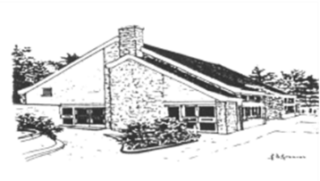 | http://nawton.n-yorks.sch.uk/

Rosedale Abbey Community Primary School – 23 on roll

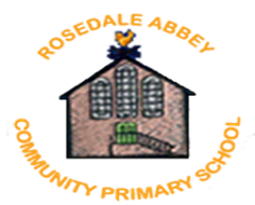 | http://rosedaleabbey.n-yorks.sch.uk/

We take pride in providing a friendly, caring, and safe learning community within which all children can flourish and make good progress in their learning. Our children lie at the heart of everything we do and every decision within the Federation is made by considering what is in the best interests of our children.

The aims of our Federation are to:
· raise aspiration
· develop strong communities
· value the diversity of each individual school

Our intention is that all Federation children have SPIRIT:

Strong sense of community
Pride in all that they do,
Independence,
Resilience and perseverance when facing challenges,
Inquisitive thinking,
Tolerance, kindness and respect to all others.

To enable all our children to enjoy their learning and to empower them to realise their potential, we offer:

- exciting learning experiences
- access to experienced, caring & committed staff
- tailored, appropriate support and challenge

We believe that we work ‘better together’.

Staff work together– improving practice and developing partnerships;
Children work together– improving learning and building relationships;
Our budget is brought together– improving resources and best value; and
Leadership works together– improving opportunities and outcomes for children.
We are constantly challenging ourselves and each other through the networks we have built between us, but also with other school communities.
We learn from each other’s strengths and support each other with areas for development.

We look forward to welcoming you for a visit.

Nichola Oxtoby
Headteacher

