|  |  |
| --- | --- |
| **Apply to join North Yorkshire Local Access Forum**  Speak up on Countryside Access |  |

Are you:

* Interested in rights of way and green spaces to explore and enjoy the countryside?
* Keen to help shape the future of rural and urban paths, and open access land?
* Able to represent landowners and managers, or access users, or other interests?
* Able to spare a morning every four months or so?

**Apply to join the North Yorkshire Local Access Forum**

People with a passion for the countryside and an interest in exploring their neighbourhoods are invited to apply to join the North Yorkshire Local Access Forum.

The Forum is an independent body that advises North Yorkshire Council, and other relevant bodies, on how people can make the most of opportunities for getting out and about in the great outdoors. It brings together representatives of land managers, users and other relevant fields or areas of interest to watch over and help shape the future of footpaths, bridleways, byways, open access land and other green spaces within North Yorkshire outside of the boundaries of the two National Parks.

If you feel that, in a voluntary capacity, you could contribute to the Forum’s work, this pack tells you more about the Forum and how you can become involved as a member.

**The Pack contains:**

* Information about what the Forum does and what being a member involves
* A role description and person specification for Forum members
* An application form for prospective members

To ensure the Forum represents the varying aspects of ‘access’ both to the countryside and in urban areas, applicants are sought who are interested in any of the following:

|  |  |
| --- | --- |
| * Walking and Rambling | * Land Owners, Managers and Farming |
| * Running and/or Orienteering | * Nature Conservation and Environment |
| * Cycling and Mountain Biking | * Rural / Local Business |
| * Equestrian pursuits (riding or driving) | * Tourism |
| * Motorised vehicle and motor bike use | * Health promotion |
| * Water based activities and sports | * Education |
| * Youth Services / Organisations | * Local Authority |
| * Disabled and Disadvantaged Groups * Ethnic Minority Communities | * Public Transport |
|  |  |

The closing date for applications is **Friday 23 August 2024 at 5pm**, with interviews to be held on **Thursday 5 September 2024**.

New Forum members will be expected to attend an induction session in mid-September.

**An outline of the North Yorkshire Local Access Forum**

**What is the Local Access Forum?**

The North Yorkshire local Access Forum (NYLAF) is an independent official body, set up as a result of the Countryside and Rights of Way Act 2000, and exists to represent the interests of everyone in the County outside of the boundaries of the two National Parks concerned with public rights of way (footpaths, bridleways, restricted byways and byways open to all traffic) and access to the countryside.

**What is the Access Forum for?**

The main role of the Forum is to advise all levels of local government, national government and other agencies by commenting officially on policy proposals and any other access issues. It focuses particularly on:

* Improving public access to land for outdoor recreation
* Encouraging the enjoyment and understanding of the countryside
* Considering the needs and concerns of land manager, tenants and owners
* Enhancing and conserving the natural environment
* Developing the rights of way network, working through the Rights of Way Improvement Plan (ROWIP)
* Broadening opportunities to use the rights of way network – considering especially those who at present, may feel excluded

**What else is expected of the Forum?**

Whilst giving advice the Forum is expected to:

* Develop a constructive and inclusive approach to the improvement of recreational access to the countryside
* Respect local circumstance and different interests while following national guidance
* Act as a bridge between different interest groups and seek a consensus wherever possible

**Who does the Forum advise?**

The Forum is a ‘statutory advisory body’ which may comment officially on relevant matters to various public agencies including:

* North Yorkshire Council
* Town and Parish Councils
* Central and Regional Government
* Highways Authorities
* Natural England

The Forum may also advise other Conservations and Environmental bodies.

**Who does the Form represent?**

The Forum is made up of local people. Individual members represent fields of interest rather than any particular organisation of which they might be a member.

The Forum has a maximum of 13 members, 2 of whom may be North Yorkshire Councillors. Members cover different fields or areas of interest, representing people who either:

* Enjoy countryside activities, such as walkers, horse riders, orienteers, runners, cyclists, motor users, climbers and wildlife enthusiasts
* Own, farm and manage the land, including landowners, tenants, farmers and other occupiers, or;
* Have an interest in other aspects such as local community or conservation issues, promoting health, the environment, public transport or tourism

**Who appoints Forum members?**

North Yorkshire Council appoints members of the Forum and provides administrative support, however the Forum is an independent statutory body. The Council will:

* Aim to ensure there is a balance between the different fields or areas of interest
* Seek people who can contribute positively and bring wider experience to the work of way users
* Recognise the need for the Forum to contain a broad base of skills and views, and for its membership to reflect the spectrum of all those who live and work in North Yorkshire

**Does the Forum take up individual issues?**

The Forum focuses upon broader concerns and does not normally comment on individual issues. However, it is able to raise issues of a more general nature with Council officers.

**How often does the Forum meet?**

Normally there will be 3 meetings a year. Members may also attend site visits, workshops, training events and conferences as appropriate.

Main Forum meetings are normally on weekday mornings. Site visits and training may be at other times.

**Are Forum members paid?**

No. All members are volunteers and give their time freely. However, members may claim reasonable out of pocket expenses incurred as part of Forum duties including travel, subsistence, childcare or care of other dependents. After being appointed, procedures for claiming mileage rates and subsistence limits will be outlined, and claim forms provided.

**Who can attend a meeting of the Forum?**

Anyone. All full Forum meetings are open to the public as observers.

**How to access agendas and minutes of Forum meetings?**

Agenda, minutes and copies of the Annual Report are available to download for the website [here](https://edemocracy.northyorks.gov.uk/ieListMeetings.aspx?CommitteeId=1219).

It is important to note the Local Access Forum is publicly accountable so the highest standards or integrity are expected from members and all Forum business is a matter of public record.

**How to apply to become a Forum member?**

Applications are welcomed from anyone with an interest in this area. To become a member you should:

* Familiarise yourself with the outline about the Forum on pages 2-3.
* Study the Forum member role description and person specification on pages 5-6.
* Complete the application form. The closing date for applications is **Friday 23 August 2024 at 5pm**, with interviews to be held in late August.
* Understand that if your application is not successful, you will be advised to that effect.
* Note that previous applicants are not required to reapply.

**How to contact the Forum?**

Contact the Forum at this address:

North Yorkshire Local Access Forum - C/O Dawn Drury

Democratic Services

North Yorkshire Council

Selby Civic Centre

Doncaster Road

Selby

YO8 8FT

Telephone: 01757 292065

Email: [dawn.drury@northyorks.gov.uk](mailto:dawn.drury@northyorks.gov.uk)

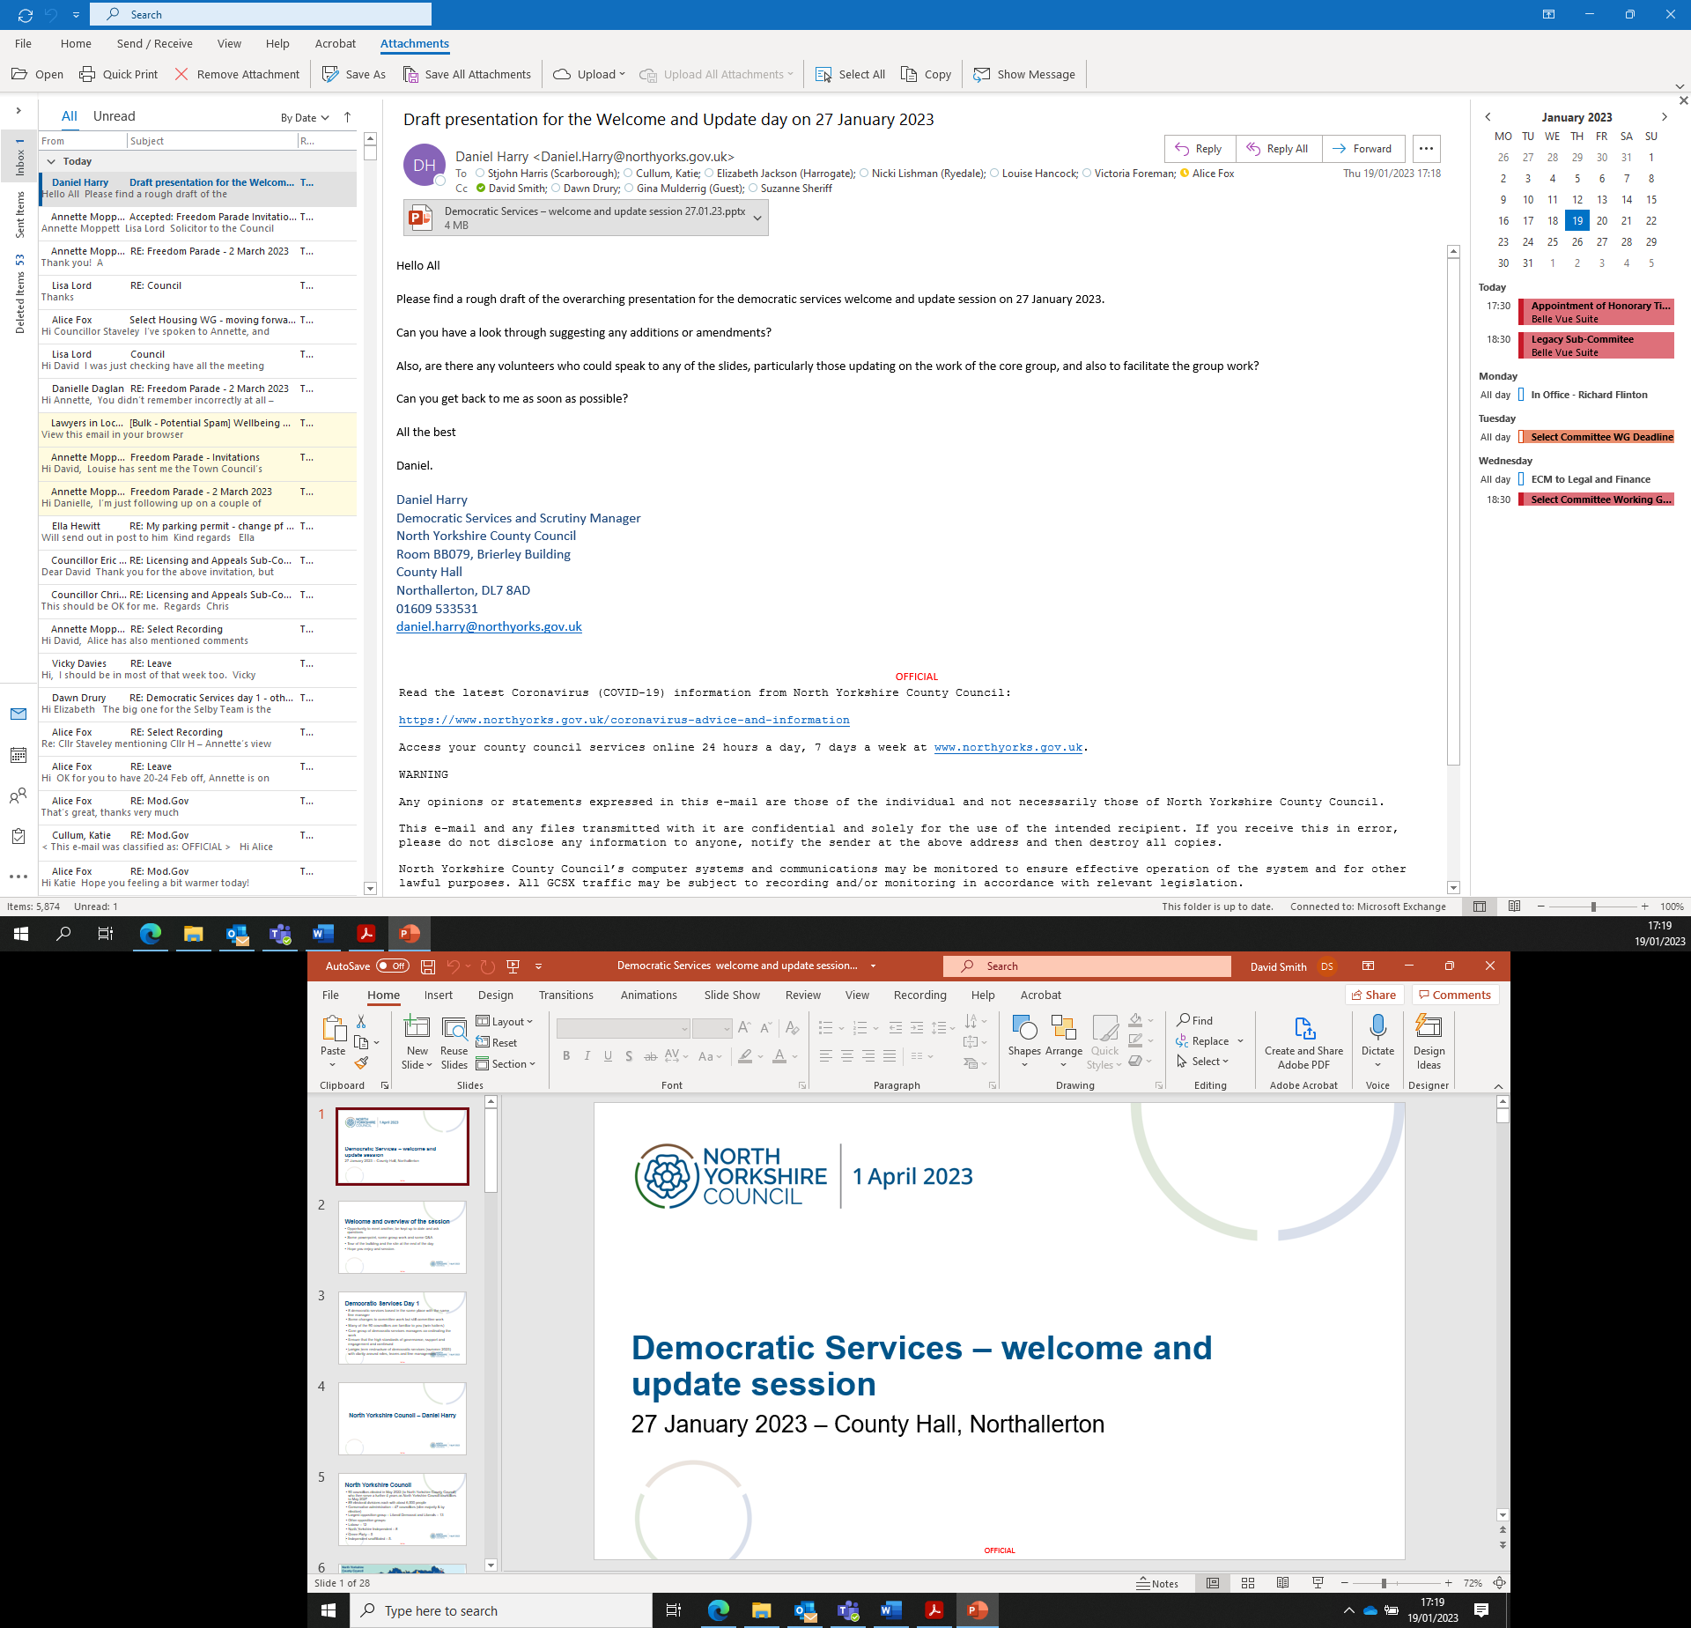

|  |  |  |
| --- | --- | --- |
| North Yorkshire Local Access Forum Member Role & Context Statement | | |
| Post Title:  Date: | North Yorkshire Local Access Forum member  July 2024 | |
| Role Context | | |
| The Countryside and Rights of Way Act placed a duty on county councils, unitary authorities and National Park authorities to establish Local Access Forums for all or part of their geographical area, or to set up a Forum jointly with other authorities.  North Yorkshire County Council established a Local Access Forum for its area outside the National Parks in April 2003 and the new North Yorkshire Council is seeking applications from individuals with an interest in improving access to the countryside.  The Forum is a statutory advisory body with a strategic role in advising the Unitary Council and other bodies such as MOD, the Highways Agency and Natural England, on matters including:   * The development of recreation and access strategies which cater for a wide range of people. * The improvement of the rights of way network. * The implementation, management and review of the statutory right of access to the countryside.   The Forum consists of 13 members, two of whom are Councillors with the remainder drawn from a cross section of local interests in the countryside. This includes recreational users, land managers and those with interests in nature conservation, ancient history, heritage, business, health, trade unions, transport and access for the less able.  The Forum is structured so that no one group predominates and the Forum endeavours to be constructive and consensual in its approach. Members of the Forum, are expected to act in an individual capacity rather than as a representative of a particular organisation. | | |
|  | | |
| Role Description | | |
| Role Purpose | | To work as a member of the Forum in a non-partisan way to advise the Unitary Council, and other bodies such as MOD, the Highways Agency and Natural England on the following matters:   * The development of recreation and access strategies which cater for he a wide range of people * The improvement of the Rights of Way network * The implementation, management and review of the statutory right of access to the countryside |
| Role and Responsibilities | | * Through membership of the Forum, contribute to improving access to the countryside * Bring relevant knowledge and experience to the Forum * To develop expertise in the areas of activity of the Forum * To contribute to and initiate debate on proposals relating to access to the countryside * To assist in the development of imaginative solutions to access issues * Listen to the views of different interests and report them to the Forum * To be prepared to work towards a consensus as an independent member of the Forum * Assist in the development of a broad understanding of Countryside and Rights of Way legislation * Represent the Local Access Forum as required |

|  |  |
| --- | --- |
| Person Specification | |
| Essential upon appointment | **Desirable on appointment** |
| Knowledge   * Understanding of countryside issues * Knowledge of issues relating to access to the countryside and the interaction between land management, recreation conservation and local transport mobility * Understanding of the range of user needs relating to local rights of way including community and visitor needs | * Understanding of how local government works and its role and responsibilities * Understanding of best practice elsewhere in relation to access to the countryside * Experience of public and service user engagement |
| Experience   * Experience of attending and participating in public meetings * Evidence of taking an active role in initiating action and making decisions | * Experience of research and data analysis * Experience of participating in high profile challenging meetings |
| Occupational Skills   * Tact and diplomacy * Resilience and the ability to cope with ambiguity and conflicting interests * Ability to develop effective working relationships and build consensus * Ability to draft consultation responses and produce briefing notes | * Good IT skills - Microsoft Office |
| Other Requirements   * Willingness to attend meetings, training events and briefings of the Local Access Forum for up to 3 years * A commitment to making the countryside more accessible and enjoyable for open air recreation in ways which address social, economic and environmental issues * Live within or on the borders of North Yorkshire * Flexible approach. Ability to travel around the whole of the County and occasionally beyond * Ability to occasionally attend meetings outside of normal business hours |  |