Post title: | Environment and Design Manager
Grade: | N
Responsible to: | Head of Planning Policy and Place
Staff managed: | Manages a team of staff across different locations
Directorate: | Community Development
Service: | Planning Service
Job family: | P&T - Professional & Technical
Date of issue: | April 2024
Job context
- The Council’s Planning Service plays a fundamental role in managing the natural and built environment ensuring that any future community and development needs of North Yorkshire can be accommodated to make it a better place in which to live and work.
- Working with a high degree of autonomy, the Environment & Design Manager will take a professional lead in driving forward the work of a team of multidisciplinary specialist environment and design functions to enable quality development across North Yorkshire. This part of the workstream will include a range of disciplines such as: archaeology, ecology, landscape, historic environment, climate change and urban design.
- Key work areas include leading on:
  - Strategic work across all specialisms on behalf of the council and with neighbouring authorities.
  - the preparation and implementation of planning policies and relevant supplementary guidance, plans and appraisals.
  - a proactive approach to the master planning and design of major sites and projects.
  - the provision of training and specialist advice to ensure legislative requirements are met.
- Such a broad breadth and depth of contact with other disciplines requires the post-holder to have a high level of understanding of many highly technical and specialist areas and to work closely with a wide range of stakeholders to enable the post-holder to carry out the requisite duties of the post.
- The post-holder has regular contact with Senior Officers across the Council, including the Assistant Director for Planning and Director of Community Development, as well as developing close working relationships with colleagues within other Directorates.
- The post-holder also has regular contact with elected Members of the Council and especially Cabinet, Executive, Government Departments and Statutory agencies.

This is a politically restricted post as defined by the Local Government and Housing Act 1989.

Job Purpose: | The core focus of this job requires the post-holder to:  - To lead the promotion, creation, protection, and enhancement of the County’s natural and built environment across a range of specialist disciplines integral to the delivery of the Council’s sustainable growth and place making agenda.  - To lead and proactively drive forward the development and implementation of relevant plans, strategies, and policies, including the council’s local plan - the blueprint for the council's place-shaping, economic and housing growth ambitions.  - Take a positive, creative and innovation approach to service delivery, using resources efficiently and effectively and exploring opportunities for income generation.  - Support the Head of Planning Policy and Place in driving a comprehensive programme of improvement, transformation and cultural change across the environment and design function and the wider Planning Service.  - Contribute to the overall operational efficiency and performance of the wider planning service  - Stay abreast of legislative changes relating to planning policy, proactively recommending, and implementing necessary changes to plans, policies and practices as required.  - Ensure a strong ‘one team’ culture and a flexible use of resources, working across all planning workstreams to delivering service priorities.

Operational management: | - Working with a high degree of autonomy, the Environment and Design Manager will take a professional lead in driving forward the work of a team of multidisciplinary specialist environment and design functions to enable quality development across North Yorkshire. Key work areas include:  - Leading strategic work across all specialisms on behalf of the council and with neighbouring authorities  - Working with the Planning Policy and Place Managers to feed into the preparation and implementation of major areas of planning policy work  - Leading the preparation of supplementary guidance, plans and appraisals relevant to the specialist functions.  - Ensuring a proactive approach to the master planning and design of major development and infrastructure projects.  - Overseeing the provision of training and specialist advice across the planning service and other relevant council services.  - Leading the preparation of Supplementary guidance and plans relevant to the specialist functions.  - Ensuring a proactive approach to the master planning and design of major development and infrastructure projects to ensure quality outcomes.  - Providing training and advice to development management officers to maximise the effectiveness of pre application discussion and to enable the assessment of planning applications.  - Co-ordinate, lead and contribute to the preparation of funding bids as necessary, including through partnership with external organisations.  - Prepare and maintain a robust evidence base to support relevant planning policies.  - Oversee the presentation of written and oral evidence and act as an ‘expert witness’ on behalf of the Council at public examinations, hearings, committees, and written appeals.  - Work with other relevant workstreams across the council to ensure alignment of ambitions, priorities, and evidence base.  - Lead effective engagement with Members, including reporting to the Executive/Cabinet both informally, and as part of the formal decision-making process.  - Deliver effective consultation and engagement through a variety of methods with communities and key stakeholders.  - Coordinate responses to relevant national and regional consultations to ensure that the interests of the Council are represented.  - Oversee the undertaking of site assessments and associated recommendations about their suitability across the full range of site typologies.  - Commission external, specialist advice and capacity where necessary.  - Ensure that customer and client feedback is collected regularly and used to inform and shape future improvement and delivery of the planning policy function.
Resource management: | - Able to work with a high degree of autonomy and limited supervision, prioritise and manage own workload effectively as well as workload of the wider team and to motivate and inspire other staff to delivery service priorities.  - Provide appropriate training and development for officers and Members across a range of disciplines.  - Work together to ensure excellent cross-service communication, shared understanding and alignment of priorities and allocation of capacity and resources.  - Support the achievement of a high performing ‘one team’ culture, driving the delivery of excellent service performance, planned outcomes, targets and objectives and continuous improvement.  - Work closely with the other Environment and Design Managers to maintain a strong focus on intelligence, performance monitoring to ensure an efficiently run workstream and effective policies and guidance to deliver the place-shaping ambitions of the council.  - Work proactively to deliver improvements and cultural change, helping to achieve an efficient, first-class planning service.  - Working closely and flexibly across other planning workstreams and relevant council functions to support plan making and related priority projects.  - Lead by example, setting clear expectations around priorities and performance, customer service, team culture and staff behaviour.  - Make and implement recommendations to deliver continuous improvement, including minor team restructures/reviews.  - Plan, direct and oversee the work of staff within your area, ensuring alignment with the service vision and agreed priorities. Ensure that 1-2-1’s and staff appraisals are undertaken on a regular basis.  - Ensure that all areas of staff management are undertaken in line with corporate policies including but not limited to recruitment and selection, appraisal, training and development, absence management, disciplinary and grievance.  - Prepare budgets for the relevant area of planning policy work, ensuring that income and expenditure targets are realistic, and proactively monitor budgets, report exceptions to the Head of Planning Policy & Place where they occur and take corrective action where required.  - Ensure that decisions are taken in line with corporate policies and guidelines, including but not limited to the Council’s Constitution & Standing Orders, Contract Procedure Rules, Budget and Policy Framework, Financial Regulations.
Partnerships: | - Contribute to national, regional, and local forums as appropriate, ensuring that statutory requirements are understood and fulfilled.  - Work closely and positively with other local authorities where joint plans, policies and guidance are being developed.  - Develop positive working relationships and maximise collaboration opportunities  - Work with a range of partners/agencies, both internal and external, to develop and maintain co-operative relationships.  - When delivering projects, ensure activities are aligned, where appropriate, with other service areas.  - Lead work with other local authorities, LEPs, Combined Authorities, and major organisations in support of the Councils objectives in relation to environment and design specialist functions and projects, including by representing the Council at meetings, Steering Groups, Delivery Boards, and other mechanisms, as necessary.  - Represent the environment and design function on behalf of the Service at policy, operational and co-ordination forums with external agencies and other Council Directorates when required.
Strategic management: | - Work alongside the Head of Planning Policy and Place and other Environment and Design Managers; supporting each other to shape, drive and deliver priority work and act as proactive leaders for cultural change and improvement in line with a shared ‘one team’ vision.  - Advise the Council on matters relating to statutory environment and design functions/projects  - Influence and shape relevant plans and strategies across the council and those of other organisations at the national, regional, and local level in order to ensure that the place shaping needs, and ambitions of North Yorkshire are understood and reflected in policy making/investment decisions  - Contribute to national, regional, and local forums on strategic planning/planning policy, ensuring that Duty to Cooperate and other statutory requirements are fulfilled
Communications: | - Represent the Council at external meetings and events on matters relating to specialist environment and design functions to ensure that the Councils priorities are well communicated and understood  - Brief relevant Executive Members and Ward Members, to ensure proactive and effective communication and decision-making.  - Influence and liaise with lead business partners as required to ensure that strategic planning and implementation of plans is carried out consistently and effectively.  - Promote the Council’s priorities, policies and Corporate Plan and positively promote the service.  - Manage challenging situations effectively and pro-actively to improve the performance of staff by maintaining communication with staff and providing the appropriate support and guidance.  - Represent the service at appropriate inter and intra agency meetings, promoting, liaising, consulting, and engaging with managers, staff, people who use our services and other stakeholders in challenging situations  - In consultation with the Head of Planning Policy & Place, respond to media enquiries as requested and appraise your manager of any matters arising which are particularly sensitive or controversial in nature.  - Deliver presentations in order to develop effective service delivery and good stakeholder relationships.  - Inform and analyse national and local policy change and communicate implications to senior operational managers and frontline staff as appropriate.
Systems and information: | - Ensure that systems and processes to support the service are consistent with the Council standards and procedures.  - Produce written reports as required including evaluation and impact statements for distribution service wide and to partners.  - Use relevant IT systems and tools to support the management, delivery, and development of services, ensuring records are accurate and current.  - Ensure government guidance and legislation are interpreted appropriately and are adhered to in a manner consistent with good practice.

Person Specification:
Essential | Desirable
Knowledge and Experience
- In depth knowledge of relevant legislation and national and regional policy and guidance and the ability to interpret complex legislation and policy, apply it in practical situations and advise senior officer, Members, the development industry, infrastructure providers, statutory consultees, local communities, and other interested parties.
- Significant experience of successfully leading a team of specialists
- Experience of a proactive and effective approach to performance management and the ability to positively drive and implement organisational and culture change
- Successful management of budgets, staff, resources, and income generation
- Sound understanding of political processes and structures, and experience of working with elected members
- Understanding of other key service areas such as economic development and transport
Occupational Skills
- Highly effective management skills, the ability to positively promote organisational policy and objectives and drive cultural change
- Able to work with a very high degree of autonomy and limited supervision, with strong risk management skills and a creative approach to problem solving
- Manage own workload effectively against a range of competing priorities as well as the workload of the wider team.
- Motivate and inspire other staff to deliver service priorities.
- Highly effective project planning and delivery skills across multiple complex and controversial projects
- Commercially aware, including the ability to develop and implement ideas for income generation.
- Take an innovative, creative, and positive approach to implementing service improvements and transformation
- Ability to contribute to the planning of resources for the Planning Service and to understand where specific programmes need to collaborate to drive change.
- Ability to develop and maintain effective partnerships both within and outside the Service.
- Ability to negotiate and influence positive place-making outcomes.
- Use exemplary communication skills with all stakeholders and at all levels of the organisation, including public speaking and presentations
- Use Professional judgements to make key decisions which have wide reaching implications.
- Ability to use a range of ICT including word, excel, PowerPoint and teams and systems for the preparation on monitoring of planning policies.

Behaviours
- Exercise at all times professional judgement, following North Yorkshire Council Policies and Guidance in the carrying out of the duties of the post and maintain an up-to-date knowledge of all legislation applicable to aspects of planning practice.
- Demonstrate the core values and behaviour of the council
Professional Qualifications/Training/Registrations required by law, and/or essential for the performance of the role  - Degree and/or Post-graduate Diploma in a relevant subject  - Chartered membership of relevant specialism (such as RIBA, CMLI, MRTPI) | - Formal project management training or qualification  - Recognised qualification in management and/or leadership
Other Requirements
- Ability to travel across North Yorkshire
- Ability to attend meetings outside of normal business hours
- Evidence of continuing professional development
- To deputise in the absence of the Head of Planning Policy and Place and to undertake any other roles as directed by them

Career progression:
- At NYC we value our employees, and as part of this we can provide wider opportunities to progress in your career. Through discussion with your manager identify areas of interest and consider avenues to progress to them, e.g., apprenticeships and work shadowing/coaching.
- As a large council we have a range of roles, across our services, and can provide a wealth of career and development opportunities to help our employees find fulfilling career development opportunities.

Structure
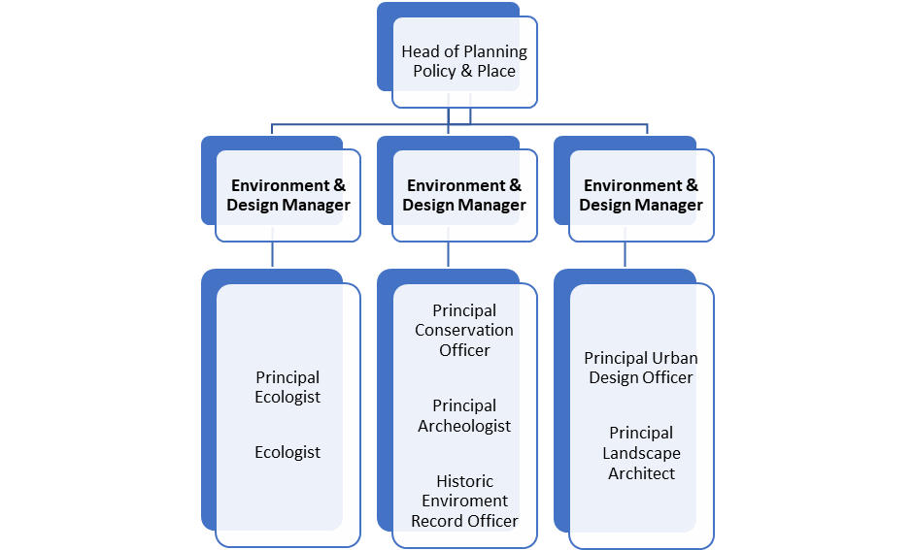

NB – Assessment criteria for recruitment will be notified separately.
You should use this information to make the best of your application by identifying some specific pieces of work you may have undertaken in any of these areas. You will be tested in some or all of the skill specific areas over the course of the selection process.

