Post title: | Plumber
Grade: | CD-H-I-JK (career graded)
Responsible to: | Team Leader
Staff managed: | Manages a team of staff across different locations at Grade JK
Directorate: | Community Development
Service: | Homes and Places
Job family: | OS - Operational Support
Date of issue: | November 2023

Job context
The Homes and Places Housing Maintenance team are responsible for ensuring the Councils social housing portfolio of circa 8,000 dwellings is maintained to meet all current regulatory and legislative standards.

Locality based operational teams focus on the following work programmes:
- Repairs Team – responsible for responsive repairs and maintenance, including out of hours call out for emergencies.
- Improvement Team – responsible for void refurbishments and adaptations.
- Construction Team – responsible for new construction and major refurbishment projects.

As a Plumber you will be allocated work within one of the above teams and will be monitored by a Team Leader for that team as required.

You will take responsibility for own area of work, ensuring behavioural, quality and safety standards are adhered to.

As part of your employment, you may be required to work in a different team or location to enable the service to meet its targets.

The postholder will be expected to undertake professional, mandatory and skills-based training to develop knowledge, skills, behaviour and expertise.

The role involves spoken and written communication, so a confident use of the English language is required.

Job purpose | The core focus of this job is to carry out essential maintenance, refurbishment or construction works on social housing stock to ensure they meet the Decent Housing Standards.
Operational Management: | At Entry Level, Apprentice/Trainee Plumber, the postholder will:  - Assist in carrying out repairs to domestic plumbing repairs  - Assist in the recording and monitoring of supplied equipment as necessary  - Work to expected Health & Safety standards and safe systems of work  - Undertake professional, mandatory and skills-based training.  On satisfactory completion of NVQ Level 2 Plumbing & Heating diploma (or equivalent), satisfactory appraisal and assessment against the behaviours framework, the postholder will progress to Plumber single trade where the core responsibilities will be:  - To carry out domestic plumbing repairs  - Record and monitor supplied equipment as necessary  - Work to expected Health & Safety standards and safe systems of work  - Undertake professional, mandatory and skills-based training.  On satisfactory completion of Level 3 Plumbing & Domestic Heating NVQ on an agreed pathway (or equivalent), a Level 2 NVQ (or equivalent) in another trade, satisfactory appraisal and assessment again the Council’s behaviours framework, the postholder will progress to Multi Skilled plumber where the core responsibilities will be:  - To carry out maintenance and repair plumbing & heating work as per work orders or specification.  - To carry out maintenance and repair work for the secondary trade in which you are trained  - Record and monitor supplied equipment as necessary  - Work to expected Health & Safety standards and safe systems of work  - Undertake professional, mandatory and skills-based training.  At this grade further specialist training may be required to meet the service needs.  On the satisfactory completion of internal Customer Service, IT and HR related courses, Housing Health and Safety Rating System (HHSRS) Training, IOSH Managing Safely & ILM 4, satisfactory appraisal and assessment against the Councils behaviours framework, and consistently demonstrating quality workmanship the postholder may progress to Mentor Plumber where the core responsibilities will be:  - To provide mentoring to plumbing and heating colleagues as required  - To ensure the apprentice fully experiences the range of tasks required to pass their qualification  - To provide required feedback in line with apprentice’s training  - To audit van stock and carry out van checks on a regular basis  - To ensure work is carried out to expected Health & Safety standards and safe systems of work  - Undertake professional, mandatory and skills-based training.  The role will come with a Council vehicle the postholder will be responsible for carrying out routine vehicle safety checks as required and must ensure compliance with requirements relating to vehicle use and maintenance.
Resource management: | At entry level and above:  - Abide by the Councils policies associated with fleet vehicles  - Carry out routine safety checks as required and report any defects promptly  - Ensure vehicle and contents are kept clean and tidy  - Drive the vehicle to maximise fuel economy, minimise wear and tear and provide safe regard to other road users  - Liaise with and assist all service colleagues to ensure the efficient and effective co-ordination of all maintenance works.  - Maintain and ensure all tools / supplied equipment are in good working order with all necessary safety checks undertaken, completing all necessary records.  - Comply with the Councils purchasing rules and responsible for allocated van stock, effective stock management and stock-taking  At Single Trade level and above:  - Manage own workload under the guidance of the Team Leader where needed  At Mentor Level:  - Responsible for supervision and training of apprentices and other employees where appropriate  - Comply with the Councils purchasing rules and responsible for allocated van stock, effective stock management and stock-taking
Partnerships: | At Entry and above  - Responsible for liaison with internal staff, tenants and merchants  At Skilled level and above  - Liaison with Team Leaders, client officers, consultants and contractors  At Mentor level  - working in conjunction with course tutors for all levels  - providing regular feedback to joiners at all levels as required  - Liaising with Building Control as needed
Communications: | At all levels:  - Able to work with and communicate effectively with customers, colleagues, contractors and suppliers.  - Liaise with Housing teams to ensure a proactive, joined-up service is delivered to the community.  - Assist in the preparations of reports and surveys e.g., for insurance / disrepair claims
Systems and information: | At all levels:  - Responsible for maintaining the safe and secure movement of data in accordance with Councils ICT and Data policies.  - Responsible for accessing and updating systems in respect of works orders and any follow up work i.e., accurate recording of time and material  At Mentor level:  - The post holder is required to undertake duties that require the use of Word, Excel, Email
Safeguarding: | The post-holder will adhere to all the Council’s Safeguarding policies and procedures

Person specification:
Essential | Desirable
Knowledge and Experience  - Relevant qualifications and experience in a specialist trade relating to domestic plumbing operations with a good working knowledge of other trade areas associated with the primary area of experience, such as, but not exclusive to joinery.  - Plumbing skills at various levels  - Joinery and other allied trade skills at Multi-Skilled level  - Experience working in a domestic setting  - Familiarity with materials, tools and machinery used in the repair, maintenance, or construction of homes  - Understanding of Health & Safety  - An understanding of Building Regulations at Multi-skilled level  At Mentor level  - Experience in the application of appropriate personnel policies and procedures  - Supervisory experience in a construction background | Dependent on the operational team:  - Experience working in a social housing repair setting  - Experience working in a new build environment, with awareness of construction related legislation and practices  - CSCS Card  - Experience in allied trades such as tiling, plastering, roofing etc would be an advantage at Multi-Skilled level
Occupational Skills  - Good verbal and written communication  - Ability to work efficiently to complete minimum daily workloads to meet business demand  - Able to conduct informal risk assessments within area of responsibility.  - Able to plan and record own workload and material use  - Customer care skills  Comfortable with the use of technology and able to use handheld mobile device  At Mentor Level  - Problem Solving Skills - Uses creativity and innovation to generate solutions for difficult issues. Identifies possible causes of problems and implements solutions to minimise future occurrence.  - Project Working Skills - Takes responsibility for specific aspects of a project.  - Resilience - Manages pressure effectively and copes well with setbacks.  - Abie to produce Risk Assessments and Method Statements for various work tasks | Dependant of post level  - Ability to read from architects’ drawings  - Asbestos Awareness at all levels  - Experience working with a repairs scheduling system
Behaviours
- A positive disposition and commitment to teamwork.
- Committed to presenting a positive image of the Council.
- High levels of customer care suitable for work in tenant's homes.
- You are as comfortable working on your own as you are as part of a team
- A commitment to the principles of continuous improvement within a developing team
- Able to communicate efficiently and courteously at appropriate levels

link to Values and Behaviours

Professional Qualifications  - See Career Progression section below for more information  - CSCS card at all levels  At Mentor Level  - IOSH Managing Safely  - HHSRS qualification  - ILM 4 | - Good standard of education including English and Maths at GCSE grades 4-9 or equivalent  - Emergency First Aid or First Aid at Work certificate
Other Requirements
At all levels
- Full driving licence.
- Comply with tool policy.
- The role may involve use of scaffolds and/or ladders, the postholder needs to be physically fit
- Able to plan and record own workload and material use
- A commitment to continuous improvement

At single trade plumber level
- Able to provide an out of hours emergency plumbing service on a rota basis

At Multi-Skilled plumber level
- Able to provide an out of hours emergency plumbing and joinery service on a rota basis.

Career progression:
- At NYC we value our employees, and as part of this we can provide wider opportunities to progress in your career. Through discussion with your manager identify areas of interest and consider avenues to progress to them, e.g., apprenticeships and work shadowing/coaching.
- As a large council we have a range of roles, across our services, and can provide a wealth of career and development opportunities to help our employees find fulfilling career development opportunities.

- This post includes progression based on a career scheme under which specific knowledge, experience training and/or qualifications are a requirement for movement between particular grades. In the case of this post, the requirements are as follows:

LEVEL ONE – APPRENTICE/TRAINEE - the post holder is required to join and successfully complete an NVQ Level 2 Plumbing & Heating diploma or Level 2 Technical Plumbing diploma and gain an Apprentice or Trainee CSCS card, moving to a gain a blue skilled worker CSCS card on completion of the NVQ level 2

LEVEL TWO - SINGLE TRADE - the post holder is required to be working towards gaining an NVQ Level 3 Plumbing & Domestic Heating on an agreed pathway, and an NVQ level 2 in another trade, preferably Joinery and gain a gold skilled worker card on successful completion of the NVQ level 3

LEVEL THREE - MULTI SKILLED - the post holder may work towards gaining further qualifications such as: -
- PAS 2030: Building Services Mechanical – boilers and heating systems.
- ASHP Installation and Maintenance
- GSHP Installation and Maintenance
- Solar Water Heating Installation and Maintenance
- MCS Accredited / certified
- CSCS card
- Rainwater Harvesting Systems

LEVEL FOUR – MENTOR LEVEL in order to reach this level the post holder is required to have successful completed internal Customer Service, IT and HR related courses, Housing Health and Safety Rating System (HHSRS) Training, IOSH Managing Safely & ILM 4.

The structure chart below shows some potential career progression opportunities linked to this particular role.

Structure
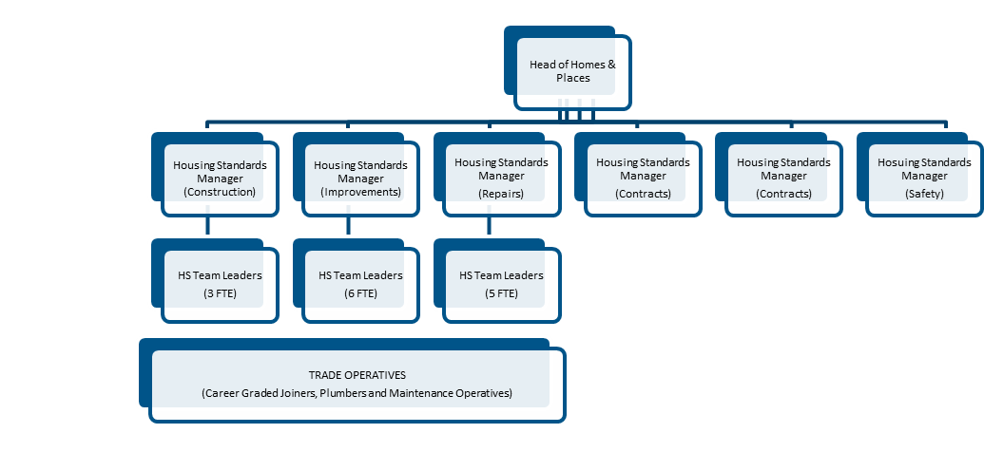

NB – Assessment criteria for recruitment will be notified separately.
Optional - Statement for recruitment purposes: You should use this information to make the best of your application by identifying some specific pieces of work you may have undertaken in any of these areas. You will be tested in some or all of the skill specific areas over the course of the selection process.

