Post title: | Planning Policy & Place Officer/Senior Planning Policy & Place Officer (Career Grade)
Grade: | Career Grade: Planning Policy & Place Officer grade JK, Senior Planning Policy & Place Officer grade L
Responsible to: | Planning Policy & Place Manager
Staff managed: | None
Directorate: | Community Development
Service: | Planning Service
Job family: | P&T - Professional & Technical
Date of issue: | October 2023
Job context
- The council’s Planning Service plays a fundamental role in managing the natural and built environment ensuring that any future development needs of North Yorkshire can be accommodated to make it a better place in which to live and work.
- The post will be pivotal in supporting the delivery of strategically important and complex projects across the North Yorkshire geography relating to major areas of policy work, including (but not limited to):
- The Local Plan for North Yorkshire
- The Minerals and Waste Joint Plan
- Neighbourhood Plans
- Other Development Plan Documents, Supplementary Planning Documents, Joint plans, Masterplans, Supplementary Plans and policy guidance
- The post holder will work with others to ensure that plans and documents are positively prepared, reviewed, delivered and managed in line with statutory requirements.
- The post-holder has regular contact with Senior Officers as well as developing close working relationships with colleagues outside of the Planning Service.
- A sound understanding of many highly technical and specialist disciplines is needed to enable the post-holder to carry out the requisite duties of the post.
- The post holder will help to deliver a proactive, customer-focused and compliant ‘end-to-end’ planning strategy service that meets statutory requirements, including contributing to the delivery of excellent performance and customer service, planned outcomes, targets and objectives and continuous improvement.
- The post holder will exercise at all times professional judgement in the carrying out of the duties of the post and maintain an up-to-date knowledge of all legislation and policy applicable to aspects of planning practice.
- The post-holder has regular contact with elected Members of the Council and especially Development Plan Committee, Government Departments and Statutory agencies.

Job Purpose: | The core focus of this job requires the post-holder to:  - Support the Planning Policy & Place function in driving forward the development and implementation of major, complex and strategically important areas of planning policy for the North Yorkshire geography in line with agreed timescales.  - Take a positive, creative and innovative approach to plan making and place-shaping, ensuring clear strategies for engagement and that statutory plans and policy documents are prepared, reviewed and managed in line with legislative requirements.  - Represent the Council through attendance and active participation in public consultation events, meetings and at formal Examination hearing sessions.  - Prepare, interpret, and present a broad range of evidence to support strategic plan making across North Yorkshire.  - Provide policy advice and support to a wide range of stakeholders, both within and external to the organisation.  - Proactively support the delivery of improvement, transformation and cultural change across the planning policy function and the wider Planning Service.  - Contribute to the efficiency and performance of the wider planning service.  - Stay abreast of legislative changes relating to planning policy, implementing changes to plans, policies and practices as required.  - Contribute to achieving and maintaining a strong ‘one team’ culture, a flexible and efficient use of resources, working across all planning workstreams to deliver service priorities.

Operational management: | All Levels  - The postholder will assist in driving forward the development and coordination of work on strategically important and complex projects across the North Yorkshire geography relating to major areas of policy work, including (but not limited to):  - The Local Plan for North Yorkshire  - The Minerals and Waste Joint Plan  - Neighbourhood Plans  - Other Development Plan Documents, Supplementary Planning Documents, Supplementary Plans and policy guidance  - Contribute towards preparing influencing, monitoring and implementing national, regional, and sub-regional policy in relation to land-use planning, infrastructure planning, and sustainable development.  - Take a locally distinctive approach to the preparation of plans.  - Prepare and maintain a robust evidence base to support planning policies.  - Exercise professional judgement and assist in developing and making recommendations in respect of planning policy.  - Work with other relevant workstreams across the council such as transport, health, social care, environmental services, climate change, housing, education and economic development to ensure alignment of ambitions, priorities and evidence base.  - Assist in working effectively with Members throughout all stages of plan preparation.  - Deliver effective consultation and engagement through a variety of methods with communities and key stakeholders.  - Provide responses to relevant national and regional consultations to ensure that the interests of the Council are represented.  - Assist in commissioning external, specialist advice and capacity where necessary.  - Undertake site assessments/inspections.  - Contribute to shaping improvement and delivery of the planning policy function.  - Assist in the project management of consultants.  - Prepare and present clear and concise reports to a range of audiences/customers.  - Promote and provide excellent customer care that meets or exceed the expectations of stakeholders, Members, customers and the community, including advice to Members of the Council and the general public on planning and related matters.  - Keep up to date with planning regulations, policy and legislation.  - Undertake any other duties commensurate with the post/grade as directed by your manager or any member of the Service Management Team.  Higher Level  - Successful development and implementation of a range of complex projects running concurrently.  - Work with Town and Parish Councils (or other relevant groups) to assist and advise on the preparation of Neighbourhood Plans.  - Prepare and deliver written and oral evidence as an ‘expert witness’ on behalf of the Council at public examinations, hearings, committees and written appeals.  - Prepare reports for and attend the Development Plan Committee and Executive Member for Planning briefings and Cabinet briefings.  - Undertake detailed site assessments and make recommendations on proposed site suitability.  - Take a prominent and proactive role in public consultation events.
Resource management: | All Levels  - Provide assistance and advice to colleagues across the Council to ensure consistency in processes and the drafting of documents.  - Carryout effective project management.  - Use initiative and excellent organisation skills to manage work priorities.  - Work together to ensure excellent cross-service communication, shared understanding and alignment of priorities.  - Support the achievement of a high performing ‘one team’ culture, contributing to the delivery of excellent service performance, planned outcomes, targets and objectives and continuous improvement.  - Work closely with others to maintain a strong focus on intelligence, performance monitoring and monitoring of planning policies to ensure an efficiently run planning policy workstream and effective planning policies to deliver the place-shaping ambitions of the council.  - Assist in delivering improvements and cultural change, helping to achieve an efficient, first-class planning service.  - Work closely and flexibly across other planning workstreams and other relevant council functions to support plan making, place-shaping and related priority projects.  - Lead by example in relation to, performance, customer service, team culture and staff behaviour.  - Contribute to delivering continuous service improvement.  Higher Level  - Provide support and guidance to less experienced staff.  - Carryout effective project management across a range of complex projects, including the efficient use of capacity and resources.  - Assist with the management of external consultants as required.  - Assist with the submission of funding bids to support service priorities.  - Understand the importance of, and work to ensure that own work priorities are consistently achieved, with minimal supervision, and that key Performance Indicators and Planning Service targets are met regarding customer and service improvements.
Partnerships: | - Contribute to national, regional and local forums on planning policy, ensuring that the Duty to Cooperate and other statutory requirements are fulfilled.  - Work closely and positively with other local authorities where joint plans, policies and guidance are being developed.  - Develop positive working relationships and maximise collaboration opportunities  - Work with a range of partners/agencies, both internal and external, to develop and maintain co-operative relationships.  - When developing new policies, ensure activities are aligned, where appropriate, with other service areas.  - Positively represent the planning policy function at policy, operational and co-ordination forums with external agencies and other Council Directorates when required.  - Assist in providing professional advice to elected Members of the Council, Town/Parish Councils and local communities/interest groups in respect of planning policy and members of the general public, prospective applicants, agents, stakeholders including specialist agencies.
Communications: | - Ensure general enquiries for advice and assistance relating to planning are responded to in both an effective and timely manner.  - Ensure that strategic planning and implementation of plans is carried out consistently and effectively.  - Promote the Council’s priorities, policies and Corporate Plan and positively promote the service.  - With the support of the Planning Policy & Place Managers, manage challenging situations and stakeholders effectively.  - Deliver presentations in order to develop effective service delivery and good stakeholder relationships.  - Inform and analyse national and local policy change and communicate implications to the Planning Policy & Place Manager as appropriate.  - Assist in representing the planning service at public meetings, working groups and/or other meetings, as directed by Line Manager and report accordingly.  Higher Level  - Assist in briefing relevant Cabinet Members and Ward Members, to ensure proactive and effective communication and decision-making.  - Represent Planning Services at public meetings, working groups and/or other meetings, and events on matters relating to strategic planning/planning policy to ensure that the Councils priorities are well communicated and understood as directed by line manager and report accordingly.
Systems and information: | - Write clear, succinct and concise reports/papers for a range of audiences on a variety of policy issues.  - Assist in ensuring that systems and processes to support the service are consistent with the Council standards and procedures.  - Use relevant IT systems and tools to support the delivery and development of services, ensuring records are accurate and current.  - Ensure government guidance and legislation are interpreted appropriately and are adhered to in a manner consistent with good practice.  - Contribute to the development of new systems, and with training, to keep up to date on IT development affecting the work.

Person Specification:
Essential | Desirable
Knowledge and Experience  - Sound knowledge of current planning legislation, policy and guidance.  - Knowledge and ability to successfully support and participate in plan making, such as policy development, engagement and public consultation, Examination and implementation.  - The ability to proactively and effectively monitor performance and positively assist in driving and implementing organisational and culture change.  - Understanding of political processes and structures.  - Understanding of both the residential and commercial property market and the importance of key links with other service areas such as economic development and transport  - Commitment to personal development  Higher Level  - Eligibility for full Membership of the RTPI  - Experience of successfully supporting and participating in plan making (policy development, engagement and public consultation, Examination and implementation).  - Demonstrable knowledge and experience of current planning legislation, policy and guidance and the ability to interpret legislation and policy and apply in practical situations.  - Understanding and experience of working with political processes and structures.  - Evidence of continuing professional development | - Degree level education
Occupational Skills
- Effective project planning and delivery skills
- Takes ownership of tasks and is highly adept at working with others.
- Effective customer care skills, including how to understand, deliver and manage customer expectations.
- Ability to work under pressure and prioritise and manage own workload.
- Analyse information from a range of sources, probing for further information or a greater understanding.
- Excellent presentation, communication and listening skills.
- Ability to persuade, influence and negotiate positively.
- Excellent organisation and record keeping.
- Able to manage challenging behaviour through appropriate channels. Acts in a manner which is likely to promote calm and reassurance.
- The ability to promote service priorities and objectives and positive cultural change
- Ability to take an innovative, creative and positive approach to implementing service improvements and transformation
- Ability to help to develop and maintain effective partnerships both within and outside the Service.
- Ability to use a range of ICT including word, excel, PowerPoint and teams and systems for the preparation on monitoring of planning policies.

Higher Level
- Excellent project planning and delivery skills across multiple complex projects
- Takes ownership of tasks and supports others, including motivating the wider team.
- Ability to persuade, influence and negotiate positively.
- Able to prevent and/or manage challenging behaviour. Taking constructive action to prevent triggers occurring and minimise identified behaviour.
- Acts in a manner which is likely to promote calm and reassurance.
- Able to manage workload and competing priorities and projects with minimal supervision.

Behaviours
- Exercise at all times professional judgement, following North Yorkshire Council Policies and Guidance and the RTPI’s Code of Professional Conduct in the carrying out of the duties of the post and maintain an up-to-date knowledge of all legislation applicable to aspects of planning practice.
- Demonstrate the core values and behaviour of the council
link
Professional Qualifications  - Educated to A level or equivalent  Higher-Level  - Degree and/or Post-graduate Diploma in Town and Country Planning or other relevant subject recognised by the Royal Town Planning Institute (RTPI)  - Eligible for full Membership of RTPI | - Degree (or equivalent) in planning or related subject  - Project management training and/or qualification
Other Requirements
- Access to transport to enable travel across North Yorkshire
- Ability to work and/or attend meetings outside of normal business hours
- Undertake any other duties as directed by the line manager
- Full Drivers Licence
- Comply with the Council’s Health and Safety and Equal Opportunities policies and relevant legislation.
- Ensure compliance with the requirements of the Data Protection Act and Health and Safety legislation.
- To comply with the requirements of General Data Protection Regulations and all such related legislation, maintaining confidentiality at all times.

Career progression:
- At NYC we value our employees, and as part of this we can provide wider opportunities to progress in your career. Through discussion with your manager identify areas of interest and consider avenues to progress to them, e.g. apprenticeships and work shadowing/coaching.
- As a large council we have a range of roles, across our services, and can provide a wealth of career and development opportunities to help our employees find fulfilling career development opportunities.
- For posts that are within a career structure, criteria to move between pay bands needs to be made clear.

Structure
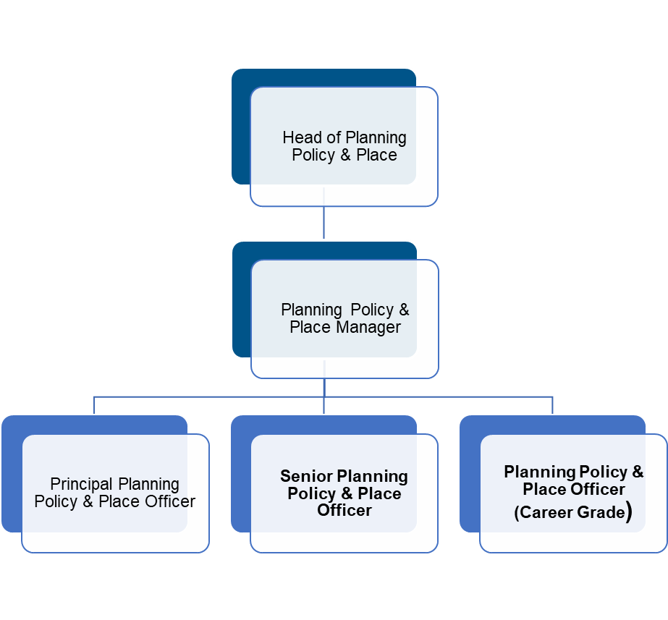

NB – Assessment criteria for recruitment will be notified separately.
Optional - Statement for recruitment purposes: You should use this information to make the best of your application by identifying some specific pieces of work you may have undertaken in any of these areas. You will be tested in some or all of the skill specific areas over the course of the selection process.

