Post title: | Principal Ecologist
Grade: | L
Responsible to: | Environment and Design Manager
Staff managed: | None
Directorate: | Community Development
Service: | Planning
Job family: | P&T - Professional & Technical
Date of issue: | April 2024
Job context
The council’s Planning Service plays a fundamental role in managing the natural and built environment ensuring that any future development needs of North Yorkshire can be accommodated to make it a better place in which to live and work.

The Principal Ecologist will promote the protection and enhancement of the County’s biodiversity, ensuring that it is an integral part of the Council’s growth and place making agenda.

You will provide specialist ecological advice to ensure statutory requirements and council objectives are met and have a key role in supporting the preparation of the council’s Local Plan, other strategies and guidance as well as providing advice on development proposals. You will help to shape the delivery of biodiversity net gain in North Yorkshire.

The Principal Ecologist is part of a multi-disciplinary team and sits alongside other specialist officers including archaeologists, Conservation Officers and Urban Design and Landscape Officers.

In carrying out your role you will work with colleagues to build relationships and understanding across the service as well as developing close working relationships with colleagues within other Directorates.
Job Purpose: | - Promote the creation, protection and enhancement of the County’s biodiversity ensuring that it is an integral part of the Council’s growth and place making agenda.  - Provide specialist ecological advice to ensure statutory requirements and council objectives are met, supporting the preparation of the council’s Local Plan  - Provide advice on the impact of development proposals where there is an impact on the natural environment and secure biodiversity net gain  - Play a proactive role in delivering the shared ‘one team’ vision

Operational management: | - Support the preparation, implementation, and review of the statutory development plan by inputting to the formulation of natural environment and Green Infrastructure policies and assessing the impact on biodiversity of site allocations.  - Prepare and update biodiversity guidance and other advisory material for agents, developers, property owners, and the general public.  - Work proactively with the National Landscapes for mutual benefit in promoting biodiversity improvements.  - Prepare and present evidence at public examinations, hearings, and local inquiries in so far as it relates to the natural environment.  - Lead the work of the SINC Panel, ensuring a transparent process for the identification, assessment, and designation of SINCs underpinned by a programme of survey work  - Work with the North and East Yorkshire Ecological Data Centre in maintaining a biological record database for the County.  - Respond to pre-application enquiries, planning applications and enforcement cases where a proposal will impact on biodiversity and ecology, with a focus on large scale, complex applications including minerals and waste and Nationally Significant Infrastructure Projects. This will include site visits to assess applications and meetings to review proposals with the applicant/consultant. Review biodiversity net gain proposals that are submitted, including providing advice on S106 agreements and planning conditions. Lead on the review of BNG Habitat Bank proposals, including the review of habitat creation and restoration proposal in line with current regulations and guidance. Liaise with legal services in the setting up of s106 for Habitat Banks.  - Provide ecological advice on habitat creation and restoration to the minerals and waste industry through the planning system  - Provide training and briefings on ecological and biodiversity net gain matters to develop in service capacity; equipping others to become more self-reliant when considering development impacts on biodiversity  - Provide ecological input to design/development briefs to ensure the effective integration of green infrastructure into new development and provide ecological advice in respect of Council owned assets  - Lead on the Planning Services responsibility to deliver and report on statutory duties under the NERC Act 2006 and Environment Act 2021  - Provide ecological advice and input into the Local Nature Recovery Strategy as appropriate  - Provide ecological advice and support to other groups, organisations, and individuals in line with the Council’s commercial agenda  - Take responsibility for own work, performance, development, and behaviours; using own initiative to ensure that expectations are met for the benefit of the Council, our customers, and our colleagues.
Resource management: | - Demonstrate commercial awareness and seek opportunities to maximise commercial opportunities within the service  - Commission additional external support and provide oversight for the work of the consultants
Partnerships: | - To represent the Council as required at internal and external meetings concerning ecological issues.  - Build effective relationships with partner organisations to promote the protection and enhancement of the County’s natural environment and biodiversity  - (no longer active)Build and develop strong working relationships across the service, and the wider council, to embed biodiversity considerations into the Council’s growth and place making agenda
Strategic management: | - Contribute to the delivery of a proactive and customer-focused service in line with our shared ‘one team’ vision  - Contribute to service transformation and improvement work and look for opportunities to continuously improve own performance.  - Contribute to the development of practice and policy within the team and across the service.  - Support the team in service planning by contributing to project plans and timescale, and by recording activity against agreed targets.  - Maintain appropriate document configuration to ensure an auditable trail of activity.
Communications: | - Communicate effectively with other practitioners and professionals, senior officers, elected Members and members of the public to ensure required outcomes are achieved.  - Represent the Council at external meetings and forums as required.  - Effective communication and negotiation with stakeholders including planning applicants, agents, consultants and statutory bodies.
Systems and information: | - Use Council IT systems including spatial data, to undertake duties and ensure record management.  - Interrogate systems to produce reports in compliance with deadlines.  - Operate all service systems in accordance with relevant adopted policies and procedures for their use and ensure that accurate records are maintained.

Person Specification:
Essential | Desirable
Knowledge and Experience
- Significant post qualification experience in assessing the ecological implications of development proposals.
- A good working knowledge of the town and country planning system (both plan making and development management)
- Experience of negotiating with a range of bodies and individuals
- Experience of effective communication using a variety of methods tailored to a broad range of stakeholders and customers, including experience of presenting evidence at examinations/inquiries and or reports to Members
- Working across organisational boundaries, developing effective relationships in order to deliver Service projects and priorities.
- Good knowledge and understanding of ecology, habitat management and restoration, survey methodologies and mitigation strategies
- Knowledge/experience of Phase one habitat surveys and protected species surveys
- Good understanding of current legislation and Policy:
  - Habitat Regulations
  - Wildlife and Countryside Act
  - Natural Environment and Rural Communities Act
  - Environment Bill
  - National Planning Policy Framework
Occupational Skills
- Inspiring, motivated team player with an engaging and positive "can do" attitude.
- Effective customer care skills, including how to understand, deliver and manage customer expectations
- Leads by example and proactively demonstrates the Council’s standards of behaviour.
- An effective communicator who is determined, positive and approachable.
- Highly self-motivated and driven to achieve challenging objectives; able to use own initiative under minimal supervision
- Strong team player and ability to encourage, support and provide challenge to others as appropriate
- Ability to manage and prioritise a wide and varied workload.
- Strong IT literacy skills with working knowledge of Microsoft applications and planning related IT systems.
- Ability to write complex reports
- Good analytical skills and the ability to interpret information and make balanced judgements/recommendations and to take action.
Behaviours
- Able to demonstrate and work in accordance with the Council's values and behaviours. link
Professional Qualifications  - Degree in Ecology or equivalent (Life sciences/Environmental Sciences  - Evidence of continuous professional and personal development. | Chartered Member of the Institute of Ecology and Environmental Management Landscape Institute
Other Requirements
- Will be required to attend site visits across the Council area.
- Will be required to work outside normal working hours on occasions.
- Able to undertake travel in connection with the post.
Career progression:
- At NYC we value our employees, and as part of this we can provide wider opportunities to progress in your career. Through discussion with your manager identify areas of interest and consider avenues to progress to them, e.g., apprenticeships and work shadowing/coaching.
- As a large council we have a range of roles, across our services, and can provide a wealth of career and development opportunities to help our employees find fulfilling career development opportunities.

Structure
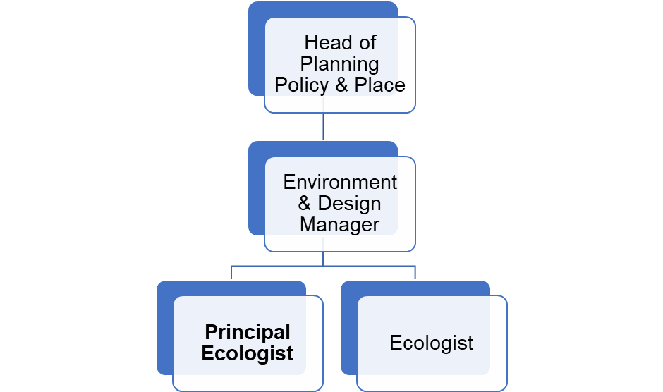

NB – Assessment criteria for recruitment will be notified separately.
Optional - Statement for recruitment purposes: You should use this information to make the best of your application by identifying some specific pieces of work you may have undertaken in any of these areas. You will be tested in some or all of the skill specific areas over the course of the selection process.

